**LAB 1**

**I. Algorithm**

**3. Convert a color image into a grayscale image.**

Explain the algorithm:

+ Each color channel has its range. For converting from RGB to Gray scale, we take average of Red, Green, Blue, but the gray scale not good. So for having a perfect gray scale, we multiply weight of each color to the right color channel, formula:

Gray = 0.299 ∙ Red + 0.587 ∙ Green + 0.114 ∙ Blue

Running code:

Open folder contains exe file in cmd, and write the following command:

Command: Lab1.exe -rgb2gray img.jpg gray.png

Input Image Your output Image

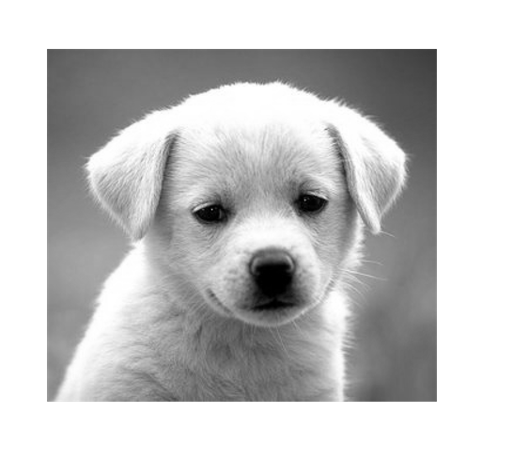

**4. Convert an image from RGB color model into HSV color model.**

Explain the algorithm:

Running code:

Open folder contains exe file in cmd, and write the following command:

Command: Lab1.exe -rgb2hsv img.jpg hsv.png

Input Image OutPut Image

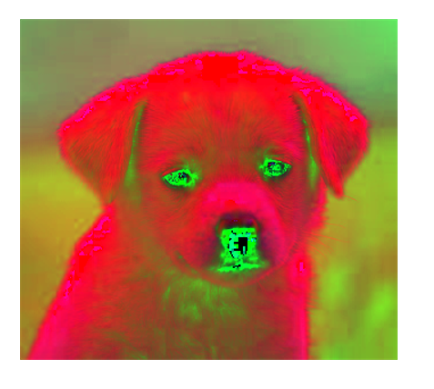

**5. Change the brightness of a color or grayscale image**

Explain the algorithm:

+ To increasing the brightness of an image, we just need to sum a constant b to all pixel in the image

Running code:

Open folder contains exe file in cmd, and write the following command:

Command: Lab1.exe -bright 30 img.jpg bright.png

Input Image OutPut Image

**6. Change the contrast of a color or grayscale image.**

Explain the algorithm:

+ To increasing the constrast of an image, we just need to multiply a constant b to all pixel in the image.

Running code:

Open folder contains exe file in cmd, and write the following command:

Command: Lab1.exe -contrast 1.75 gray_input.jpg gray_contrast.png

Input Image Output Image

**7. Draw histogram of a color or grayscale image**

Explain the algorithm:

+ First we need to calculate the histogram of each channel in color img, or for one channel in gray image. Then depend on this histmatrix we draw line.

Running code:

Open folder contains exe file in cmd, and write the following command:

Command: Lab1.exe -drawhist img.jpg drawhist.png

Input Image Output Image

Command: Lab1.exe -drawhist gray_input.jpg gray_drawhist.png

**8. Equalize histogram of a color or grayscale image.**

Explain the algorithm:

+ Step1: calculate the number of pixel in the chanel

+ Step2: Calculate the PDF(probability density function ) for the number pixel in step 1

+ Step3: Calculate the CDF(Cumulative distribution function) for the number pixel in step 2

+ Step4: Multiply the max value to number of pixel in step3

+ Step5 :Rounding up the solutions in step 4, we will an matrix

+ Step6: Using matrix in step5 to map original image to new image (solution)

Running code:

Open folder contains exe file in cmd, and write the following command:

Command: Lab1.exe -equalhist gray_input.jpg equalhist.png

Input Image Output image

Command: Lab1.exe -equalhist img.jpg img_equal.png

**II. References**

<http://support.ptc.com/help/mathcad/en/index.html#page/PTC_Mathcad_Help/example_grayscale_and_color_in_images.html>

<https://www.geeksforgeeks.org/program-change-rgb-color-model-hsv-color-model/>

<https://docs.opencv.org/3.2.0/de/d25/imgproc_color_conversions.html>

<https://www.codespeedy.com/hsv-to-rgb-in-cpp/>

<https://gist.github.com/yoggy/8999625>

<https://github.com/opencv/opencv/blob/master/modules/core/include/opencv2/core/saturate.hpp>

<https://www.youtube.com/watch?v=oMYwmDbGUG8&ab_channel=ComputerVisionAcademy>

<https://answers.opencv.org/question/54672/count-number-of-peaks-in-histogram/>

<https://gregorkovalcik.github.io/opencv_contrib/tutorial_histogram_calculation.html>

<https://www.youtube.com/watch?v=uqeOrtAzSyU&ab_channel=ECAcademy>